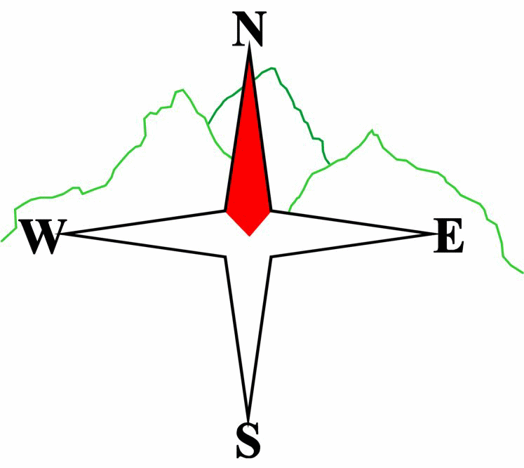***Blairgowrie & District Hillwalking Club***

**www.bdhc.org.uk**

**West Drumochter (Balsporran)**

**16/02/2024**

**O.S. Map No**: 42

|  |  |  |  |  |
| --- | --- | --- | --- | --- |
| **Bus times:** | **Blairgowrie** (**Wellmeadow**): **08.00 am** | | **Alyth** (**Square**): **07.45 am** | |
|  |  | | | |
|  | | | | |
| A Walk – Geal-charn & A’ Mharconaich | | | | |
| Start at the Balsporran Cottages car park NN 628 792. Walk west over the railway. Continue on track (ignoring the first turn-off to the right). Shortly after crossing a small bridge look for a track heading right at 621 790. Take this up onto the long heathery ridge of Geal-charn. The angle eases as the summit plateau is approached. Track westerly to reach the summit **M 917m**. From summit head SW then S to reach the bealach between the two hills 592 766. The route then heads steeply SE to reach the broad ridge of A’ Mharconaich. Follow this NE to reach its summit **M 975m**. Head N for app 600 m before following the initially rocky/steep NE ridge back towards the start. | | | | |
| Approx. distance: 12.1 km | | Total ascent: 750 m | | Min. **walking** time: 4¼ hrs |
|  | | | | |
| B Walk – Geal-charn | | | | |
| Start as A walk but take first path on right which climbs onto the E ridge of Creagan Mor. Once on the ridge take the path E until it meets the N ridge of Geal-charn. Ascend this to summit **M 917 m.** Descend the S ridge until meeting, at 593 770, a path heading NE into Coire Fhar. Follow this path above Allt Coire Fhar down to re-join the outward path towards the railway crossing and back to start. | | | | |
| Approx. distance: 11.8 km | | Total ascent: 520 m | | Min. **walking** time: 3¾ hrs |
|  | | | | |
| C Walk – Bruar Falls to Blair Atholl | | | | |
| Drop off outside House of Bruar on minor road B8079 from Blair Atholl. NN 823 661. Start by walking up to Bruar Falls. Cross the first bridge then turn north uphill keeping to the east bank of the river to junction at 820 667. Here turn east for 500 m then take a track at 825 665 to the north through Glen Banvie Wood. Keep on this for c.3.5 km until meeting a track from the N at 826 697. Turn E and gradually descend Glen Banvie to Old Blair. Follow signs for Blair Atholl and the Atholl Arms Hotel to be picked up by coach. | | | | |
| Approx. distance: 13.8 km | | Total ascent: 286 m | | Min. **walking** time: 5¼ hrs (@ 3 kph) |

The next club walk is on the **9th March** to S Loch Tay starting at 08.00 am (Blairgowrie) and 07.45 am (Alyth).

Other information/events: The Club’s AGM/dinner follows this on the 28th March

**Please note that the Minimum walking times are based on reasonably fast walkers and assuming good conditions. The times do not include stops or breaks.**

## **In poor weather conditions or if members are not comfortable walking at 4km/hour then alternative or shorter routes should be considered.**

|  |  |
| --- | --- |
| IMPORTANT: YOUR SAFETY IN THE HILLS | |
| **The Committee reminds members and guests of the following important points:** | |
| * You are responsible for your own safety * Club officials are not trained mountain leaders * Are you fit enough to complete your chosen walk in the available time? * Know where you are going on the walk and follow the route on your map. * Know how many are in your party and stay together | * Ensure you have enough food plus emergency rations * Carry a map & compass, survival bag, torch, whistle and small first aid kit. Know how to use them. * In winter conditions you must carry an ice axe on high level walks (club rule). You are also recommended to carry crampons. * **Learn** how to use your equipment. |
|
|
|
|
|  |
| **Club officials will be happy to give advice on any of these points if requested.** | |